Brother Caius Character Profile

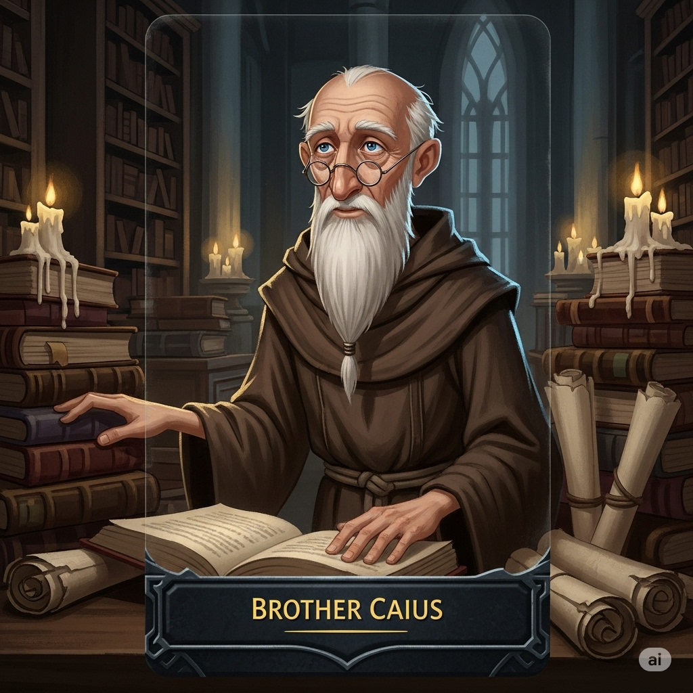



Where Light Fades: Brother Caius - Definitive Character Profile (Finalized)

I. Basic Information
- Full Name: Brother Caius
- Age: An older, experienced Paladin.
- Gender: Male
- Race/Species: Human
- Occupation/Role: Brother in the Order of the White Flame, serving as a mentor, advisor, and the Master-at-Arms.
- Affiliations: Order of the White Flame.

II. Physical Appearance
- General Description: An older man with a kind face etched with deep knowledge and piercing, intelligent eyes. His build is slender, and his posture is slightly stooped from years spent over books, belying his underlying strength.
- Distinguishing Features: A long, white beard and small, round spectacles. His hands sometimes tremble when he is forced to confront things that cannot be explained by logic or lore.
- Typical Attire: Simple and functional brown robes, often stained with ink, befitting a scholar more than a warrior.
- Symbolism: He wears an ancient key around his neck, representing his role as a keeper of history and a seeker of hidden truths.

III. Speech and Dialogue Style
- Vocabulary & Tone: His speech is formal and wise, often using metaphors, parables, and references to old texts. His voice is calm, measured, and soft, but carries an undercurrent of concern and authority.
- Nonverbal Communication: Often strokes his beard while contemplating, pauses to think deeply before speaking, and frequently adjusts his spectacles.

IV. Personality & Beliefs
- Core Personality Traits: Thoughtful, intelligent, scholarly, questioning, patient, and deeply observant.
- Strengths: His wisdom, extensive knowledge, and profound insight are his greatest assets.
- Weaknesses/Flaws: His primary flaw is a reluctance to interfere directly, preferring to offer cryptic guidance rather than take direct action. This stems from a deep-seated fear of causing unintended harm, born from witnessing past mistakes.
- Beliefs & Values: His core values are truth, wisdom, and compassion. He has a deep faith in the ideals of the Order but is willing to question its dogma, having been troubled by discrepancies in its teachings for years.

V. Psychological Profile & Backstory
- Motivations: Driven by a deep need to understand the world and to guide others toward the Order's true, uncorrupted values. He sees the great potential for good in Kaelen and is motivated to help him save the world, believing he may be the key to breaking a cycle of failure.
- Core Wound / Trauma: Witnessing past mistakes and failures of the Order, including the cover-up of the Eldrin affair, which he was powerless to stop at the time. This has left him with a touch of resignation and a profound fear of history repeating itself.
- Backstory Summary: Brother Caius has dedicated his life to the Order, finding solace in study. His extensive learning has given him deep insight into the Order's secrets and flaws, including his suspicion of Valerius's true nature and ambitions. He is one of the very few who knows the full, damning truth of the Eldrin affair.

VI. Relationships
- Kaelen: Caius serves as a trusted mentor and confidant. He is deeply concerned about Kaelen's internal struggle and the influence of Oathbringer, seeing him as a promising but troubled Paladin who must find his own path. He offers cryptic warnings designed to make Kaelen think for himself.
- Valerius: A fellow Elder whom Caius views with deep concern and suspicion. He recognizes Valerius's ambition and sees him as a danger to the Order's soul, creating a tense and adversarial professional relationship. He knows Valerius is a danger but respects his vast understanding of the world.

VII. Abilities & Fighting Style
- Abilities/Skills: Possesses a high innate magical potential rooted in an exceptionally strong Inner Flame. He is a masterful combatant with extensive knowledge of combat, strategy, and the White Flame.
- Magic: He is a master of Light Magic, capable of creating Advanced Wards, using Judgment to reveal intentions, inspiring allies with Command, performing Banishment rituals, and unleashing a devastating White Flame Burst. His Beacon of Hope and Restoration Touch are exceptionally powerful.
- Fighting Style: Though rarely seen, his style would be the perfect embodiment of the Order's highest martial and magical ideals: precise, defensive, and overwhelmingly powerful when necessary, executed with the calm wisdom of a true master. He is not a frontline brawler but a strategic and formidable force.

Brother Caius's Abilities and Magic Capabilities

Brother Caius's Abilities and Magic Capabilities

Brother Caius is the Master-at-Arms of the Order of the White Flame, possessing a high innate magical potential rooted in a very strong Inner Flame. He has years of experience and extensive knowledge of combat, strategy, and the White Flame, making him a formidable and wise leader.

I. Core Principles and Sources of Brother Caius's Magic:
- The Inner Flame (Internal): Brother Caius possesses a very strong and disciplined Inner Flame. This is his inherent spark of goodness, resilience, and willpower, which he has cultivated over years through rigorous training and service. His Inner Flame is his primary source of individual strength and connection to the Light.
- The White Flame (External): As Master-at-Arms and an experienced Paladin, Brother Caius has a profound connection to the White Flame. He acts as a powerful conduit for this external, objective source of spiritual energy, drawing upon its collective strength for guidance, protection, and inspiration.
II. Accessing Brother Caius's Magic:
- Innate Ability: He has a high inherent potential for magic, a natural talent that has been refined through years of dedication.
- Training: His training as a Paladin and subsequent role as Master-at-Arms means he has undergone the most rigorous training the Order offers, including:
  - Mastery of Meditation and Mental Exercises: To maintain an unyielding Inner Flame and sharp willpower.
  - Advanced Physical Exercises: To ensure peak endurance and control over his body and magic.
  - Deep Study of Ancient Texts: He possesses extensive knowledge about the White Flame, Heartstones, and advanced magical practices, likely surpassing most other Paladins.
  - Mastery of Ritualistic Practices: He knows and can perform complex rituals, gestures, incantations, and ceremonies of the Order.
- Rituals and Objects: He likely uses a staff or scepter as a symbol of his authority and as a magic conduit, allowing him to focus and amplify his abilities.
- Emotional State: Brother Caius's emotional state is disciplined and resolute. He rarely lets emotions cloud his judgment, which allows for consistent and powerful channeling of Light Magic. He likely carries the weight of the Order's past mistakes, but this manifests as resolve rather than weakness.
III. Brother Caius's Light Magic Abilities:

Brother Caius's Light Magic abilities are advanced and powerful, demonstrating a masterful command of the White Flame. They manifest as a bright, white, or blue glow.
- Basic Healing: He can effectively close wounds, mend broken bones, and alleviate pain.
- Protective Wards: He can create powerful and long-lasting wards to protect areas or individuals from harm. These are superior to basic protective wards.
- Light Burst: He can emit powerful flashes of light to blind multiple enemies or illuminate vast dark areas.
- Strength of Will: A passive ability that significantly enhances his physical strength and resilience, fueled by his exceptionally strong Inner Flame.
- Smite: He can imbue his weapon (or hand) with concentrated White Flame energy for devastating strikes.
- Weapon Enhancement: He can imbue his weapon (likely his staff/scepter or a sword) with potent White Flame energy, making it exceptionally sharp and effective against dark creatures.
- Shield of Faith: He can conjure robust and focused protective barriers for combat, capable of absorbing significant magical or physical impact.
- Tactical Awareness: A highly developed sense of awareness of his surroundings, allowing him to anticipate enemy movements, identify weaknesses, and react with strategic precision.
- Blinding Strike: He can execute swift, precise attacks that emit an intense flash of light, momentarily incapacitating multiple opponents.
- Righteous Fury: He can unleash a controlled, yet potent, burst of strength and speed, allowing him to rapidly overwhelm opponents.
- Advanced Wards: Beyond simple shields, he can create complex, multi-layered wards to protect strategic locations or large groups, offering sustained defense.
- Judgment: A powerful spell that channels the White Flame to judge the intentions of an individual, revealing their true nature (good or evil) and potentially exposing illusions or deceptions.
- Command: He can inspire and bolster the courage and determination of other Paladins, significantly strengthening their Inner Flames and enhancing their abilities in battle.
- Banishment: A powerful and potentially dangerous ritual to banish dark creatures or corrupted objects back to the Shadow Realm. His years of experience would make him one of the few capable of performing this safely.
- White Flame Burst: He can unleash a devastating wave of pure White Flame energy, incinerating nearby enemies, dispelling complex illusions, and purifying corrupted areas.
- Beacon of Hope: He can create a powerful, far-reaching aura of light that not only repels profound darkness but also mends grievous wounds and profoundly bolsters the spirits of many allies, inspiring them to fight on.
- Restoration Touch: He can channel pure White Flame energy to heal even the most grievous wounds, restore vitality, and mend the spirit, potentially reviving those near death.
- Valiant Charge: He can charge forward, enveloped in an exceptionally radiant aura, capable of knocking back numerous enemies and significantly bolstering the courage and resolve of allies in his wake.
IV. Limitations:
- Heartstone Destabilization: Despite his mastery, magic remains less predictable and more dangerous due to the Great Sundering's impact on the Heartstones.
- Overuse Exhaustion: While highly resilient, excessive use of his powerful magic can still exhaust him physically, mentally, and spiritually.
- Concentration and Inner Flame: Though highly disciplined, his spells can still fail if his concentration is severely broken or his Inner Flame is critically weakened, though this is rare for him.
- Susceptibility to Nyx: Light Magic, even at his level, is less effective against the raw, primordial power of Nyx or beings fully consumed by it. He cannot "destroy" Nyx itself with Light Magic, only repel or contain its manifestations.

